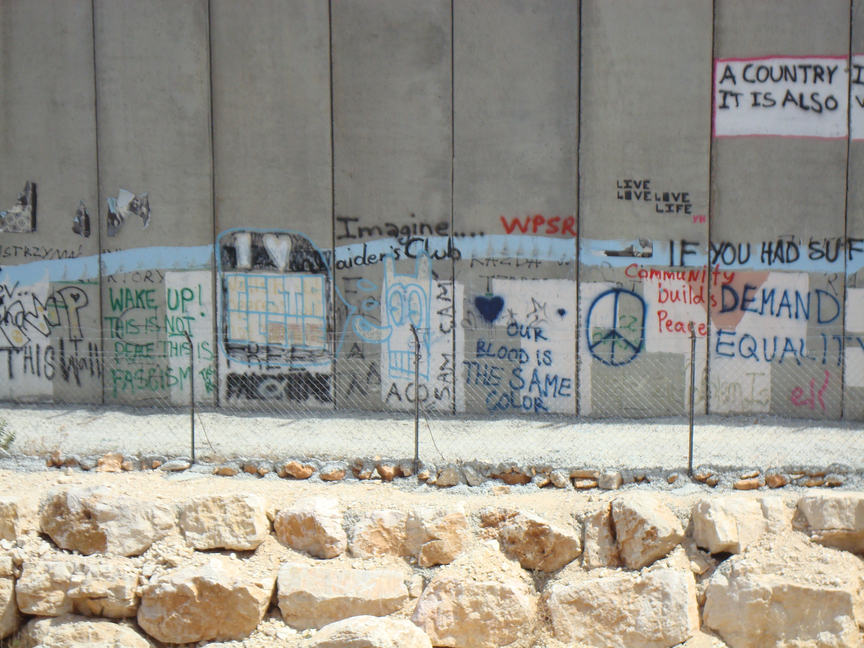
  Political Geography Specialty Group
  Newsletter 2013
  Issue Date
PGSG President MAT Coleman; secretary/treasurer reece jones |  | In This Issue

Student Rep Column Page 2

Dear Political Geography colleagues,
Since our meeting last year in New York City we have lost a cherished friend and colleague, Neil Smith. Neil is the reason why I am a geographer, and surely I am not alone in this. When I started graduate school, it was not in Geography. I was at the Institute of Political Economy at Carleton University in Ottawa, Canada. Simon Dalby and Fran Klowdaswky introduced me to the discipline by getting me to read Neil’s Uneven Development, and there was no looking back. I am so thankful. Indeed, when I was asked to go back to my alma mater several years ago to give a talk, I was asked who else should be invited to come, and Neil topped that list. It was an honor to share the stage with him at that event.
Neil has been on my mind a lot lately. My colleague at Ohio State, Joel Wainwright, has been doing a lot of reading and writing about the new interest in “human geography” at the Department of Defense. Several months ago Joel pointed me to the September-October 2012 issue of Pathfinder, the National Geospatial Intelligence Agency’s in-house magazine (https://www1.nga.mil/MediaRoom/Publications/Documents/Pathfinder%20Magazines/2012/2012_sept-oct.pdf). I am sure that some of you have already had a chance to see the issue. But in case you haven’t, the issue features a cover story on the importance of human geography to fighting future conflicts. In short: “Human geography tells ‘when’ and ‘where’ to put boots on the ground”. That the DoD is interested in human geography, of course, should not be surprising to geographers. As Neil discussed in his marvelous biography of political geographer Isaiah Bowman, it is impossible to make sense of the discipline without considering its constitutive links with military practice. It is geopolitics all the way down, and has arguably always been so.
But I still find this new development around the question of “human geography” surprising. In Geography, as more broadly across the social sciences and humanities, the “cultural turn” of the 1980s was criticized by many for its emphasis on geographical and historical contingency, and for its embrace of qualitative, so-called “squishy”, methods. It is strange to think of the Pentagon as an ally in this battle, some thirty years later, but there you have it. Indeed,
Continued p. 4
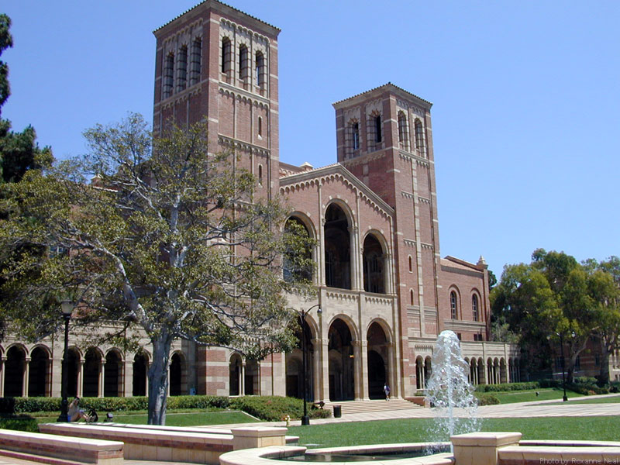

President’s Column
by Mat Coleman, The Ohio State University
PGSG Pre-Conference UCLA
The 26th Annual PGSG pre-conference will be held Monday April 08 at UCLA.
Page 5

PGSG Award info
The deadline for the Graduate Student Paper competition and Dissertation Enhancement Awards are March 15
Page 3

Student Rep Column
by Jeremy Slack, University of Arizona
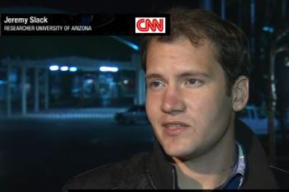
Few things in graduate school are as agonizing as the long journey toward thesis and dissertation topics. While many of us have an idea of what we want to study upon entering a program, few ideas can withstand the barrage of exciting, eye opening research we read over the first few years so that when we come to choose our topics, the topic, our magnum opus we invariably freeze. The truth of the matter, this will most likely not be your crowning achievement. Do you remember Marx’s dissertation? No? You mean that well-worn copy of Capital is alone on your shelf without “The Difference Between the Democritean and Epicurean Philosophy of Nature?” Forgive me for being flippant. I am sure more than one colleague will mention how I will never truly understand some facet of Marxist thought having mocked this tome, but my point still stands: the dissertation does not define you for the rest of your life and career. However, let’s take a moment to examine what graduate research can do, what it can accomplish and how we, as graduate students interested in political geography can have an important impact on our field. I also want to discuss some disturbing trends within geography and academia as a whole.
First, it is important to note that I am against programmatic statements about research topics or approaches, and prefer to share some of the things that I have found useful and important in my own work. Far be it from me, or anyone else to presuppose that one type of research or another will lead to important findings while another won’t. I certainly have opinions and preferences but I don’t want to preclude any approaches to research. For example, I would like to hear more voices from study participants in political geography. There is always a tendency to aggregate our work and generalize with meta-theoretical implications, which causes people’s lives and stories to disappear. And while there are well founded concerns involved with representing people and speaking for them in academic literature, is it ever going to be more ethical to write about people’s problems or lives without including their words?
This is only one of a myriad of ethical issues imbedded in our work that must receive careful scrutiny. The first of which is how can we use our time in a way that is useful for as many people as possible? What questions do the people you work with want to know? As we choose topics, the first step in research is always to get close to others involved in similar or overlapping fields. This can be one of the most anxiety producing steps to research because one never knows how people react and academics, activists and NGOs are notoriously territorial. Being open to change, stepping back from that NSF proposal and listening to the gaps in knowledge for people that live with these issues, rather than focus squarely on the gaps in academic literature goes a long way to opening doors and hearts. For instance, I have been working on issues of deportation and immigration for about five years now and one major aspect of my work has been to produce generalizeable quantitative data about people’s experiences crossing the U.S. Mexico border, being apprehended and processed through the complicated legal system and returned to Mexico. This involves engaging in knowledge production that is not always comfortable for a critical human geographer, but all the bells and whistles of sampling protocols, response rates, probability weights make a difference in how valuable this information can be for a wide range of interested parties, be they activists, law makers, NGOs or think tanks. This involved inviting people to comment on our questions, as well as spending years interviewing people that had actually gone through this experience.
While this example is not for everyone, and obviously you have to do something that makes you happy as well, it is important that we think beyond the academy in terms of the value of our work. There are thousands of archives that could use a little organizing, press releases that need editing, records that need keeping and stories that people want to tell. While this does not have to be your magnum opus, it is a time to devote more attention to one singular project than you will likely have again in your lifetime. You can do a lot with it even if you don’t do everything.
However, this presents us with yet another problem: how do we get support to do research? This becomes extremely problematic as more and more private and military interests begin supporting academic work. While, I strongly assert that there is no such thing as “clean” money, there are gradations of evil. Political geography is right in the middle of this crisis. From the use of mapping in anti-terrorist and drone warfare to the controversial Bowman Expedition, it is hard to escape the commentary. In my University there is a center run by the Department of Homeland Security. They recently conducted a study with migrants in detention awaiting deportation about how to insure that they do not return to the U.S. The noted similarities between this and my own work frighten me, but of greater concern is the production of knowledge whose sole intent is to cause harm to people that participate. By taking advantage of University pedigrees for knowledge production viewed as objective truth, diverse interests see value in manipulating research designs and findings. As graduate students we are often not in a position to influence these currents within our universities, however, we all must recognize the devastating effects of these types of projects since we all represent our universities wherever we go. It is impossible to escape the negative perception presented by these actions. At best this can result in extra levels of suspicion about our intents and at worst physical danger.
To conclude, the research we engage in as graduate students, whether it is a theoretical treatise, archival work, ethnography or quantitative GIS work, make something of it that you can be proud of, but something that doesn’t crush you. The pieces on the side where you get to engage with people, and do something that might mean something, even a little bit for someone else can change everything. Watch out for the traps and pitfalls. Be careful of hidden agendas and consequences of our work. While I assert that limiting some of the pressure for a dissertation or thesis is a good thing, understanding that real world consequences do exist and the political usage of the work we produce is beyond our control.

PGSG AWARDS
Student Paper Awards
Description: The student paper competitions are open to all students who have written and presented a research paper on a topic in political geography.
Guidelines are as follows:
1. The competition is open to all students, however a student may not receive a Student Paper Competition award more than once during her/his tenure as a student. See also 8a below.
2. The entries must be research papers and not complete theses or dissertations. Papers must not be longer than 15 pages double spaced 12 point font, plus bibliography.
3. Entries must be on a topic in political geography.
4. Paper entries must have been presented at a professional meeting during the period beginning with the first day of the previous AAG Annual Meeting and concluding with the last day of the next AAG Annual Meeting.
5. Digital copies of papers must be submitted electronically to the PGSG's Student Paper Award Committee chair by Friday March 15, 2013.
6. Submissions will normally be divided into Masters and Ph.D. student divisions.
7. Submissions will be judged on their written clarity, methodological and theoretical soundness, and their contributions to research in political geography.
8. All monetary prizes are awarded at the discretion of the Student Paper Award Committee. Awards will normally include:
A. A regional student-paper award: for a paper presented at a Regional AAG meeting; award will be $100 for the top paper(MA or Ph.D. level, only one award); a student may not win both student paper awards;
B. Doctoral Student Award ($250),
C. Master's Student Award ($250),
D. up to three Honorable Mention awards ($50).
9. The results of the Student Paper Award competitions will be announced to the winners just prior to the annual AAG meeting. The awardees (including any Honorable Mention awardees) will be invited to attend the annual AAG Awards Luncheon at the expense of the PGSG. The awards will be formally announced at the PGSG business meeting and payment will take place shortly thereafter. The awardees' names and paper titles will be forwarded to the AAG for publication in the AAG Newsletter.
10. Any questions pertaining to eligibility will be resolved by the Student Paper Award Committee.
Graduate Student Paper Committee:
Corey Johnson, Committee Chair, University of North Carolina - Greensboro, corey_johnson@uncg.edu
Steve Radil, Ball State University, sradil@bsu.edu
Helga Leitner,University of Minnesota, helga.leitner-1@umn.edu
Dissertation Enhancement Award
The PGSG Dissertation Enhancement Award is granted annually to PGSG student members. Two awards of $1000.00 each will be awarded at the discretion of the Dissertation Enhancement Award Committee. Interested students should prepare a mini-dissertation proposal for submission to the Dissertation Awards Committee.
Guidelines are as follows:
1. The competition is open to all Ph.D. students who are members of the PGSG.
2. The DEA proposal should be 8-10 pages in length total (single or double spaced) and include sections covering the research question(s), theoretical issues, conceptual framework, methodology, relevance to political geography, and a budget describing how the $1000.00 would be used.
3. A proposal submitted for the PGSG DEA award may NOT be submitted to any other AAG Specialty Group for a dissertation enhancement award.
4. If a student has already incurred expenses listed in the budget by the time of the award announcement, the student may use the DEA to cover those expenses.
5. The DEA proposal should be crafted from the student's dissertation proposal which has been or will be submitted to the Ph.D. committee within the 2012-2013 academic year.
6. To enable full consideration of all submissions, entrants should send electronic copies of their DEA proposals to the Dissertation Enhancement Award Committee Chair listed below by Friday March 15, 2013.
7. The results of the DEA competition will be announced to the winner prior to the annual AAG meeting and the winner will be invited to attend the annual AAG Awards Luncheon at the expense of the PGSG. The award will be formally announced at the PGSG business meeting and payment will take place shortly thereafter. The winner's name and dissertation title will be forwarded to the AAG for publication in the AAG Newsletter.
8. Questions concerning the competition may be directed to the members of the Dissertation Enhancement Awards Committee.
Dissertation Enhancement Award Committee:
Robert H. Watrel, Committee Chair, South Dakota State University, robert.watrel@sdstate.edu
Shannon O’Lear, University of Kansas olear@ku.edu,
Gabriel Popescu, Indiana University South Bend gpopescu@iusb.edu
Non-Student Awards
Julian Minghi Outstanding Research Award. This award will be given to the author(s) of a journal article, book chapter, or book published during the previous calendar year that makes an innovative, original contribution to the conceptual and/or methodological embrace of political geography.
- Stanley D. Brunn Young Scholar Award. This award will be given to an individual who has received her/his Ph.D. within the past ten years, in honor of contributions that have generated new interest in the subfield and/or opened up new areas of inquiry for political geographic research.
- Richard Morrill Public Outreach Award. This award will be given to an individual who has used her or his political geographic expertise to affect change (in public thought or public policy) beyond the academy.
General Information:
1. All awards will be based on nominations made to the President of the PGSG, with award decisions to be made by the PGSG Board.
2. For all awards, the field of political geography will be defined according to the breadth of topics covered in the Political Geography chapter of the “Geography in America at the Dawn of the 21st Century” volume.
3. For each award category, a maximum of one award will be conferred each year, with the announcement to be made at the PGSG Business Meeting taking place the next Spring (e.g., the announcement for the Outstanding Research Award for 2012 will be made at the Spring 2013 Business Meeting). For each award category, if there are no nominees whom the Board views as deserving of merit, no award will be made.
4. Each award recipient will receive a $50 check to honor her or his achievement.
5. Decisions regarding who receives awards will be made by the PGSG Board. The PGSG Board reserves the right to determine whether a nominee (or a nominated publication) falls within the scope of political geography.
6. Nominations by Board members are permitted.
7. Awardees need not be PGSG or AAG members, although awardees will be strongly encouraged to join both groups if they are not already members.
President’s column cont. from p. 1:
my reading of the NGA’s newly stated interest in “human geography” is that it is on precisely the terrain of geographical difference and contingency (in the form of culture areas, primarily). Political geographer Derek Gregory has written on this development as the “rush to the intimate”, by which he means the substitution of geographically-specific “cultural awareness” and “cultural intelligence” for prior doctrines of overwhelming kinetic, i.e. deadly, force. Not that, mind you, the kinetic has suddenly disappeared.
What has me so interested in this development is that I don’t hear more political geographers talking about it. Derek, as noted above, is an important exception. He writes, it seems daily, about these issues on his geographicalimaginations.com (which incidentally has got to be one of the most impressive geography blogs on the web). Jeremy Crampton has also written about these issues on his Open Geography site. But for the most part the cables have been quiet.
Anthropology makes for a very good counterpoint. Anthropologists have, since 9/11, been under the microscope in terms of the Pentagon’s “rush to the intimate”. But as is to be expected from anthropologists, the laundry was aired publicly and productively, and the discipline’s ties to the Pentagon are now in question. For example, in 2007 the Association of American Anthropologists, in part, found that their members’ participation in the so-called Human Terrain System was “an unacceptable application of anthropological expertise”. The point is that there was a substantive conversation about these issues in Anthropology.
I think geographers should make space to talk about these issues, and in detail rather than in passing. I would argue that this is particularly the case for political geographers, who have always had to struggle with the geopolitical constitution of their subfield. Again, to cite Neil’s American Empire, political geography as we know it was defined by the high wall bricked between geopolitics and political geography in the wake of 1945.
If I could put my two cents in, what is going on now under the moniker of “human geography” is immensely important for political geographers if nothing else because the push to incorporate “adversary culture” into military operations, and so make use of geographers (as well as anthropologists, linguists, and political scientists), signals a final and fatal blow to the idea of the university as an ivory tower. The conceptualization of the university as a privileged space somehow apart from the world has arguably always been wrongheaded, in terms of, for instance, the actually existing political economies of research and pedagogy. But now so more than ever. Surely this warrants a detailed discussion among us.
And what better place to have this conversation than in Los Angeles! Please make sure to check out the preliminary schedule for this year’s AAG meeting in The City of Angels at http://www.aag.org/cs/annualmeeting/program. Please also note that the program for this year’s PGSG preconference (Monday April 8 at UCLA) is also online at http://www.politicalgeography.org/aagannounce.html. I’d like to remind PGSG members that you don’t have to be a presenter in order to attend the preconference, so come to Los Angeles a day earlier and spend some time with us at UCLA. It’s a great campus, and we’ve got a fantastic line up of papers scheduled. I am personally looking forward to our closing plenary session on “Current controversies and future directions in political geography”, featuring Joanne Sharp, John Agnew, Simon Dalby, Natalie Koch, and Sara Koopman. Reece and I would like to especially thank Adam Moore in the Department of Geography at UCLA plus the Department of Geography at UCLA for all their help in setting up the preconference. The preconference would simply not be possible otherwise.
In closing, and seeing as I am about to be deposed as your president, I’d like to thank the PGSG governing board and members for their work and ideas during my tenure. I’d especially like to thank Reece, who has worked tirelessly to keep our finances in order, run the website, and among other things help with organizing the preconferences. I couldn’t have asked for a better secretary-treasurer. As I look back over the past two years, I’m especially proud of the spending changes that Reece and I inaugurated with respect to graduate student travel and research funding. The PGSG preconference and the main AAG conference are important networking and professionalizing sites for graduate students, and I am very happy to say that the PGSG has been able to expand its travel funding and research awards for graduate students at precisely the same time as departments have had to cut down on all sorts of graduate student support. I really hope that going forward the PGSG can double down and commit to even more spending to facilitate graduate student travel and research.
I look forward to seeing you in Los Angeles. And please remember to get involved. The PGSG is nothing without an active membership. I would especially love to see you at the business meeting. It’s not as dour as it sounds!
Mat Coleman
Columbus, OH

26th Annual PGSG Preconference
The PGSG and the Department of Geography at UCLA are very pleased to announce that the 2013 PGSG Preconference will be held at UCLA in Westwood, Los Angeles on Monday April 8 2013.
The preconference will be held at the UCLA Faculty Center, located at 480 Charles E. Young D
$20 registration fee for faculty and postdocs, receipts provided; no fee for grads
Room and bldg details, link to map @ http://www.politicalgeography.org/aagannounce.html
SCHEDULE
8:00 – 8:30 Check-in, registration, and continental breakfast (Faculty Center)
8:30 – 8:45 Welcoming remarks (Sequoia)
8:45 – 10:45 Sessions I and II
10:45 – 11:00 Coffee break
11:00 – 12:45 Sessions III and IV
12:45 – 2:00 Lunch
2:00 – 4:00 Sessions V and VI
4:00 – 4:15 Break
4:15 – 6:00 Session VII and VIII
6:00 – 6:30 Reception (Bunche Hall 1261)
6:30 – 7:30 Plenary panel
8:00 – PGSG Annual Dinner (details TBD)

8:45 – 10:45 Sessions I and II

Session I: Violence and security - Redwood Room
Chair: Shannon O’Lear, Department of Geography, University of Kansas

1 ) Operating in the margins: USAID, (alternative) development, and the (counter)insurgent geographies of the Cold War
Wes Attewell
Department of Geography, University of British Columbia

2) Mechanisms explaining the spatio-temporal diffusion of violence in sub-Saharan Africa
Andrew M. Linke
Department of Geography, University of Colorado

3) Transecting security and space in Phnom Penh
James D Sidaway, Till F Paasche and Chih Yuan Woon
Department of Geography, National University of Singapore

4) Salvadoran security and the convergence of public and private protection
Peter D. A. Wood
Department of Geography
Florida State University

5) The travels of a tactic: where will international accompaniment for peace go next?
Sara Koopman,
Balsillie School of International Affairs, Wilfrid Laurier University

Session II: Borders - Sequoia Room
Chair: Mat Coleman, Department of Geography, Ohio State University

1) Settler colonialism on the Arizona/Sonora border: queer theory, indigenous geographies, and the nation-state
Carrie Mott
Department of Geography, University of Kentucky

2) Deepening the dialectical landscape: narco tunnels and the political economy of the subterranean U.S.-Mexico border
Cynthia Sorrensen
Department of Geography and Geosciences, Texas Tech University.

3) Behind the smoke and mirrors: post-deportation interviews about apprehension, detention and deportation procedures
Jeremy Slack
School of Geography and Development, University of Arizona

4) The (neo)liberal subject of contemporary U.S. border enforcement
Geoffrey Boyce
School of Geography and Development, University of Arizona

5) The geopolitical meaning of a contemporary visual art upsurge on the Canada-U.S. border
Anne-Laure Amilhat Szary
Institut de Géographie Alpine, Université Joseph Fourier

10:45 – 11:00 Coffee break

11:00 – 12:45 Sessions III and IV

Session III: Rethinking nation and place - Redwood Room
Chair: Reece Jones, Department of Geography, University of Hawai’i Manoa

1) Synecdoche and the city: state, citizen, and spectacle in Kazakhstan
Natalie Koch
Department of Geography, The Maxwell School, Syracuse University

2) The resilience of the “territorial trap”: state-led representations and ordinary performances in producing Taiwanese and North Korean national spaces
Alessandro Tiberio
Department of Geography, University of California, Berkeley

3) Negotiating language borders and linguistic borderlands
Virginie Mamadouh
Department of Geography, Planning and International Development Studies, University of Amsterdam

4) Rethinking Bosnian postcoloniality: challenges of the Europeanization discourse
Danijela Majstorović
Center for European and Eurasian Studies, International Institute, UCLA

Session IV: Affect, agency, and aliens - Sequoia Room
Chair: Jason Dittmer, Department of Geography, University College London

1) Action theory after the practice turn: assembling the future
Huib Ernste
Human Geography, Radboud University

2) Locating agency: reading against the grain
Cheryl Gilge
College of Built Environments, University of Washington

3) David Foster Wallace and radical democracy
Mark Purcell
Department of Urban Design & Planning, University of Washington

4) Sovereign alien says "What?": sovereignty in The Avengers, Avatar, and District 9
Ben Schrager
Department of Geography, University of Hawai’i Manoa

12:45 – 2:00 Lunch

2:00 – 4:00 Sessions V and VI

Session V: Encounters and memory - Redwood Room
Chair: Adam Moore, Department of Geography, UCLA

1) Human geography’s polymorphous spaces of interaction
Veit Bachmann, Department of Human Geography, Goethe-University Frankfurt

2) Summer in the Soviet Union: the Artek youth delegations of the National Council of American-Soviet Friendship and the spatial regulation of encounter
Ulrich Best
Canadian Center for German and European Studies & Department of Geography, York University

3) Koza as a borderland: memories of the anti-US riot and place-based
identities
Takashi Yamazaki
Graduate School of Literature and Human Sciences, Osaka City University

4) On affective heritage: posthumanism and the Australian War Memorial
Jason Dittmer, Department of Geography, University College London
Emma Waterton
Institute for Culture and Society, University of Western Sydney

5) Where’s the state? Memory, identity & power in the Lebanese capital
Ali Hamdan
Department of Geography, UCLA

Session VI: Law and Policy - Sequoia Room
Chair: Fred Shelley, Department of Geography, University of Oklahoma

1) Enactments of foreign policy expertise: insights from Ukrainian think tanks
Ievgenii Rovnyi
Department of Human Geography, Goethe University of Frankfurt am Main

2) Intra-party gerrymandering and the shape of congressional districts
Kenneth C. Martis
Professor Emeritus of Geography, West Virginia University

3) ‘Counting’ at home or in the big house: prisoners and the decennial census in the U.S.A.
Matthew L. Mitchelson
Department of Geography and Anthropology, Kennesaw State University

4) The hybrid legal geographies of war crimes trials
Alex Jeffrey
Department of Geography, University of Cambridge
Michaelina Jakala
School of Geography, Politics and Sociology, Newcastle University

5) Targeting military lawyers
Craig Jones
Department of Geography, University of British Columbia

4:00 – 4:15 Break

4:15 – 6:00 Session VII and VIII

Session VII: Environmental and medical geographies - Redwood Room

Chair: Corey Johnson, University of North Carolina - Greensboro

1) The (not so) phantom menace: reviewing Kaplan’s Revenge of Geography
Shannon O’Lear, John Biersack, David J. Trimbach, Nathaniel Ray Pickett, Department of Geography, University of Kansas

2) Virtual climate justice: assessing regional effects of climate engineering technologies
Thilo Wiertz
IASS, Heidelberg University

3) Cape York’s world heritage dilemma: power dynamics on the environmental frontier
Nick Skilton
Department of Geography, University of Wollongong

4) The mapping of provinces and populations: socio-medical geographies of the early Turkish republic
Kyle T. Evered
Department of Geography, Michigan State University
Emine Ö. Evered
Department of History, Michigan State University

5) TBD
Michael Webb, OSU

Session VIII: Law, maps, transnationalism … and anarchy! - Sequoia Room
Chair: Anne-Laure Amilhat Szary, Institut de Géographie Alpine, Université Joseph Fourier

1)Islamic activism in Bosnia and Herzegovina and Serbia's Sandžak of Novi Pazar: transnational networks and territorial strategies
Mahmood Khan
Department of Geography, UCLA

2) Placing Palestine: maps, territories, & imaginaries
Karen Culcasi
Department of Geology and Geography, West Virginia University

3) Somewhere between law and implementation: the politics of immigration statuses between occupied territories
Brittany Cook
Department of Geography, University of Kentucky

4) Locating resistance in multi-level migration governance regimes: a US/EU comparison
Michael Collyer
Department of Geography, University of Sussex

5) Why a radical geography must be anarchist
Simon Springer, Department of Geography, University of Victoria

6:00 – 6:30 Reception

UCLA Department of Geography, Bunche Hall 1261

6:30 – 7:30 Plenary panel: Current controversies and future directions in political geography

Chair: Mat Coleman, Department of Geography, Ohio State University
Panelists:
John Agnew, Department of Geography, UCLA
Joanne Sharp, School of Geographical and Earth Sciences, University of Glasgow
Simon Dalby, Balsillie School of International Affairs, Wilfrid Laurier University
Natalie Koch, The Maxwell School, Syracuse University
Sara Koopman, Balsillie School of International Affairs , Wilfrid Laurier University

